DBMS

**Team Names:**

* Ahmed Nabil Mohamed Anwar (7)
* Ziad Hisham Ali Abdel-Hameed Saad (19)
* Yehia ElSayed Mohamed (59)
* Youssef Ahmed Sayed Gabriel (61)

Report:

**Description:**

* DBMS software which manages databases and handles SQL statements on them.

**UML (Design):**

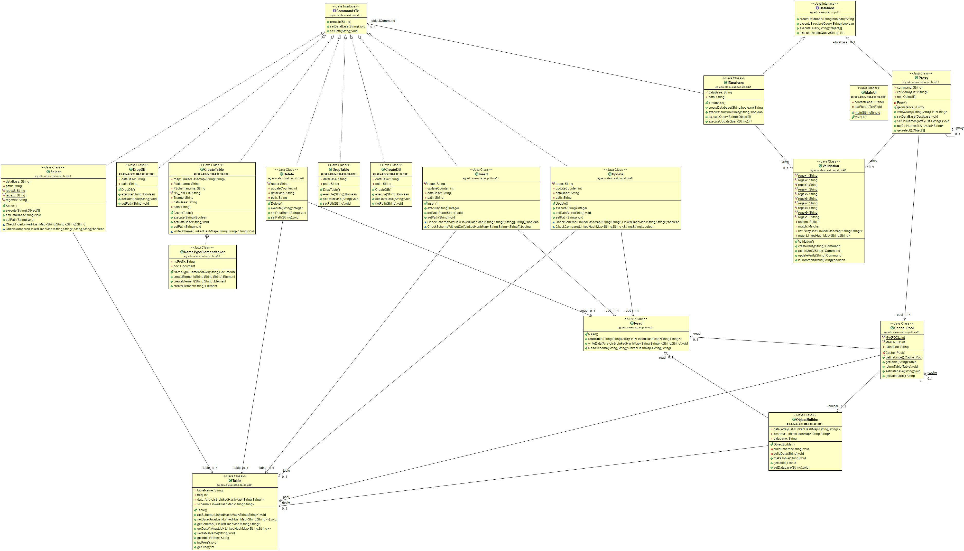

**Assumptions:**

* The statements handled are in the form of the well-known SQL statements any differences will be considered a syntax error.
* If the type of the column is varchar, the value should be between single quotes.

**User Manual:**

* When the program opens a window will appear with a text area which can’t be edited by the user, and a text field in the bottom in which the user can write the SQL statements.
* First the user should create a database or use a database which he’s already created using the SQL statement “CREATE DATABASE database_name” without double quotes.
* Then the user will be able to create or use already existed tables using the following SQL statements (all statements are case insensitive) :
  + To create a new table “CREATE TABLE table_name(col1 type, col2 type, …)”, where type is int or varchar.
  + To select something from a table “SELECT col1, col2, … FROM table_name”, and you can replace the column names with “ * ” to select all columns and you can add a condition simply by adding “WHERE col = value”.
  + To insert a row into a table “INSERT INTO table_name (col1, col2, …) VALUES (value1, value2, …)”, and you can remove the column names.
  + To delete a row from a table “DELETE FROM table_name WHERE col = value”, you can delete all records from a table simply by removing the “WHERE” clause.
  + To update a table with new values “UPDATE table_name SET col1 = value1, col2 = value2, …”, and you can add a condition simply by adding “WHERE col = value”.
  + To drop a table “DROP TABLE table_name”.
  + To drop a database “DROP DATABASE database_name”.
* The text area will show all the actions performed and any error messages will also appear on it after the user presses “ENTER” on the keyboard, note: the user can write “clear” in the text field to clear the text area, and he can press “ESC” to clear the text field.
* The user can save the changes he made to the tables by simply pressing “Ctrl+S”.
* If a user use the “select” SQL statement a dialog will popup with a table showing the data which the user has selected.
* If a user changes the database he is working with, the previous changes will be automatically saved.

**Design Patterns:**

* Façade: The whole application is structured using the façade design pattern.
* Singleton: The façade class called “Proxy” and the “Cache_Pool” class are singleton classes.
* Builder: The builder design pattern is used in building tables from their files on the hard disk.
* Command: The command design pattern is used in executing all the commands interpreted from the queries, the Command interface is generic to accept various return types of different commands.
* Pool: The pool design pattern was used in making cache for the tables which the user is currently using.

**Screen shots:**

